**Experiment # 11**

Analyzing First RC Transient Circuit

**Objectives:**

In this, we will analyze first RC circuit using PSPICE software.

**RC Circuit:**

A resistor–capacitor circuit (RC circuit), or RC filter or RC network, is an [electric circuit](https://en.wikipedia.org/wiki/Electric_circuit) composed of [resistors](https://en.wikipedia.org/wiki/Resistor) and [capacitors](https://en.wikipedia.org/wiki/Capacitor). It may be driven by a [voltage](https://en.wikipedia.org/wiki/Voltage_source) or [current source](https://en.wikipedia.org/wiki/Current_source) and these will produce different responses. A first order RC circuit is composed of one resistor and one capacitor and is the simplest type of RC circuit.

RC circuits can be used to filter a signal by blocking certain frequencies and passing others. The two most common RC filters are the [high-pass filters](https://en.wikipedia.org/wiki/High-pass_filter) and [low-pass filters](https://en.wikipedia.org/wiki/Low-pass_filter); [band-pass filters](https://en.wikipedia.org/wiki/Band-pass_filter) and [band-stop filters](https://en.wikipedia.org/wiki/Band-stop_filter) usually require [RLC filters](https://en.wikipedia.org/wiki/RLC_filter), though crude ones can be made with RC filters.

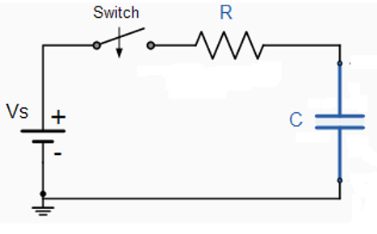

**Pspice:**

PSPICE is a computer-aided simulation program that enables you to design a circuit and then simulates the design on a computer. As this is one of its main purposes, it is used extensively by electronic design engineers for building a circuit and then testing out how that circuit will simulate.

PSpice makes it easier to validate component yield and reliability, verify electrical performance, and optimize your designs.

**Apparatus:**

➢ A computer with PSPICE installed on it

**Procedure:**

1. Open schematic program of PSPICE.
2. Click on the “Get New Part” button on the toolbar.
3. Type ‘r’ in the search bar and place the resistors on the white sheet.
4. Type ‘vdc’ in the search bar and place it on the white sheet.
5. Type ‘c’ in the search bar for capacitor and place it on the white sheet.
6. Type ‘switch’ in the search bar for switch (tclose=0.1ms) and place it on the white sheet.
7. Type ‘gnd-earth’ and place it on the white sheet.
8. Now arrange these components on the white sheet according to the circuit diagram as following.

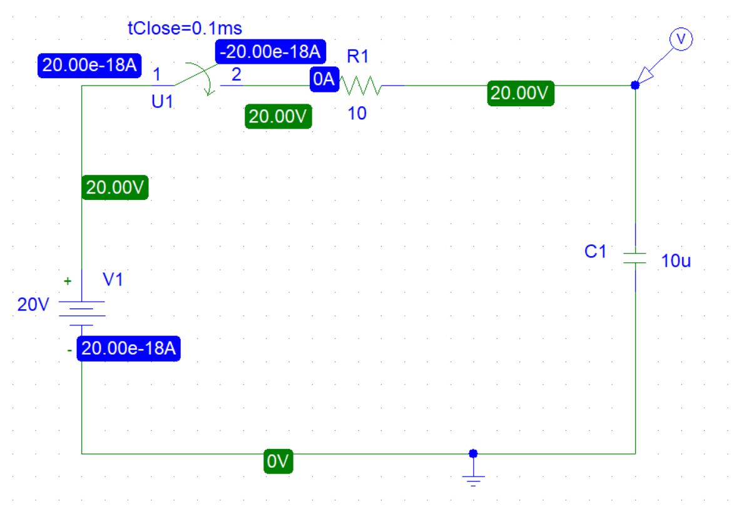

RC Circuit Diagram

1. Click voltage/level Marker button and place on the specified position in the circuit.
2. Now click Setup Analysis button.
3. A window will open check the transient box and then click on the transient button.
4. Set the Print step and final time to a suitable values.
5. Check the ‘skip initial transient solution’ box.
6. Click OK.
7. Now simulate the circuit by clicking the simulate button.
8. A graph will appear which will show the operation of your circuit. You can add more curves to your graph by clicking on Add trace button.

**Graph of circuit:**

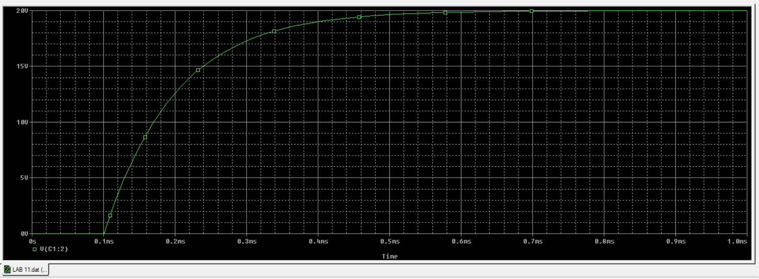

RC Circuit Graph

**Conclusion:**

The time constant of capacitor from three RC circuit were successfully determined experimentally and compared to their theoretical values which were determined mathematically